Editorial

Cuomo must demand a permanent gerrymandering ban - or else
Veto threat gives governor powerful leverage for reform
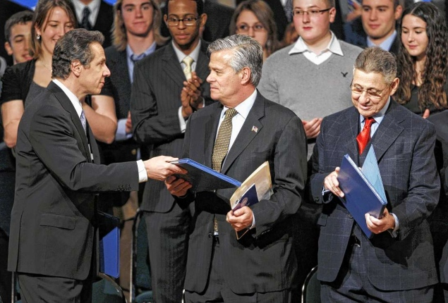
Mike Groll/AP
To stop gerrymandering, Gov. Cuomo must play tough with Senate Majority Leader Dean Skelos and Speaker Sheldon Silver.

Tuesday, February 28, 2012, 4:00 AM

Gov. Cuomo holds the ultimate weapon in the battle against gerrymandering — his threatened veto of district maps drawn in ridiculously partisan fashion by the Legislature.

He must void the absurd boundaries drawn by the Assembly and Senate and turn map -making over to the courts — except in the unlikely event that lawmakers radically alter their work and establish long-term reforms.

As things stand, Assembly Speaker Sheldon Silver’s Democrats and Senate Majority Leader Dean Skelos’ Republicans conspired in drawing districts with grossly uneven populations that maximize incumbent protection.

The boundaries are so ridiculous that it’s clear they were drawn to facilitate fake compromises. (Gee, we hadn’t noticed that we mapped Central Park into the South Bronx!)

The only scenario that might conceivably justify withholding the veto is reform that ends gerrymandering not just for 10 years, but permanently.

First, the Legislature would have to agree to revising its maps wholesale to produce districts that come close to what the courts would generate.

Second, the Legislature would have to give first passage to a well-designed constitutional amendment guaranteeing that all future maps would be drawn by an independent, nonpartisan commission. Lawmakers would also have to pledge to pass the amendment again next year, sending it to voters for approval in November 2013.

Third — as insurance against bad faith — the Legislature would have to pass a statute enacting the same independent, nonpartisan redistricting system in the event the amendment does not pass.

Pulling off all of that without hedges and loopholes would be miraculous. If Cuomo makes the pigs fly, great. Otherwise, he’ll have to veto.

.AD-064

